Example insert statements

Neighbourhood
INSERT INTO neighbourhood(Neighbourhood_ID, Neighbourhood_Name)
VALUES (21, "random_neighbourhood");
-- The name is just an example since every neighbourhood from harlem is written down.
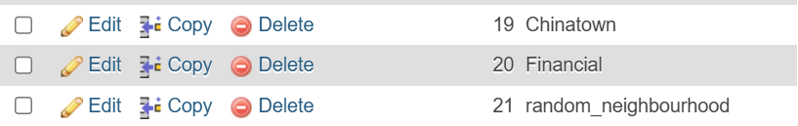

Cityblock
INSERT INTO cityblock(Block_ID, Neighbourhood_ID, Population, Infected_Count, Recovered_Count)
VALUES (55, 20, 20000, 19000, 1000);

/* Recovered count and infected count are based on the rates on the infection rates of the ingame virus with 95% for infection rate and 5% for recovery rate */
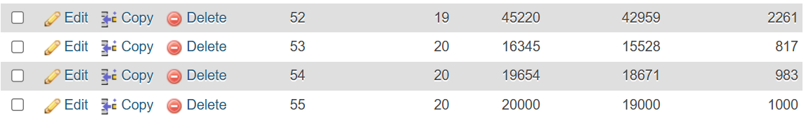

InfectionEvent
INSERT INTO infectionevent (Event_Number, Block_ID, People_Infected, Event_Description)
VALUES (11, 19, 7, "Airborne particles spread at a major museum exhibit");
Transmission
INSERT INTO transmission(Event_Number, Method)
VALUES(2, "Shared Surfaces");
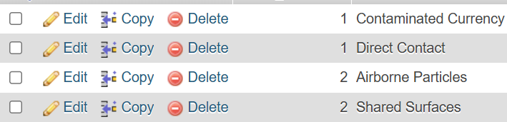

Query 1: using like
SELECT * FROM neighbourhood WHERE Neighbourhood_Name LIKE "%Side";
-- Neighbourhood names ending in side
Result:
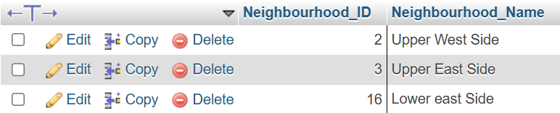

Query 2:
Purpose: To compare the initial infection count of the outbreak event to the final number of people infected in that same block.
SELECT infectionevent.Block_ID, Event_Number, People_Infected, Event_Description, Infected_Count
FROM infectionevent
INNER JOIN cityblock
ON infectionevent.Block_ID = cityblock.Block_ID
WHERE People_Infected > 7;
/*
This query will compare a subset of blocks to show the number of people who were initially infected at a block and show the number of people infected after the month by using data from the cityblock table
*/
Result:

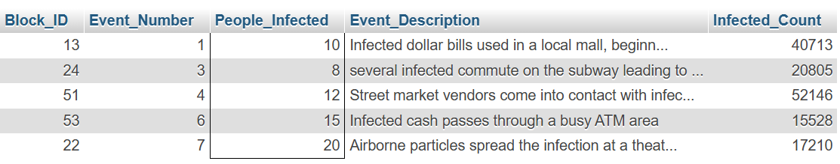

WITHOUT the where statement:
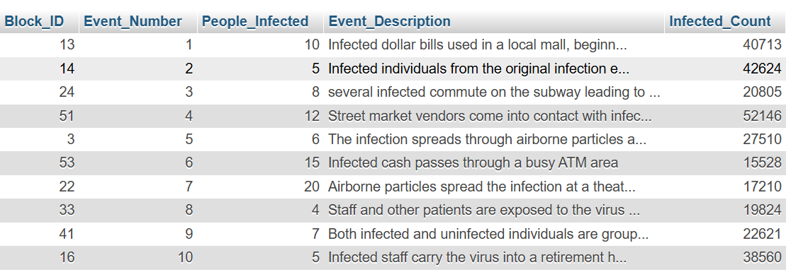

Query 3: using “>”
Purpose: We want to use this query to see which blocks have the highest infected count (over 40000).
SELECT Block_ID, Neighbourhood_ID, Population, Infected_Count
FROM cityblock
WHERE Infected_Count > 40000;
-- WHERE is used as a filter to show the blocks with the highest infected count
Result:
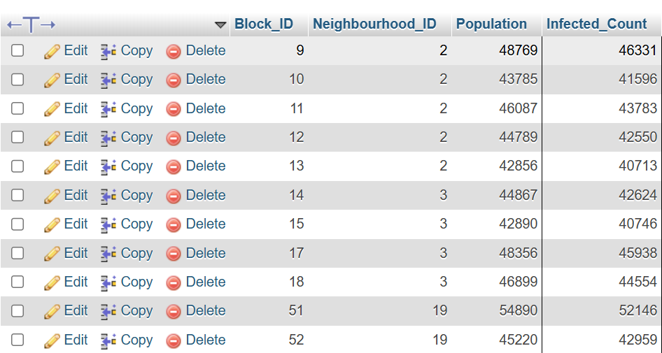

Query 4:
Purpose: We want to see the total number of blocks as well as the total number of people infected across each neighbourhood.
/* SUM is the total number of infected and COUNT increments the individual instances of each block in each neighbourhood. */

SELECT Neighbourhood_ID, SUM(Infected_Count), COUNT(Block_ID)
FROM cityblock
GROUP BY Neighbourhood_ID;
Result
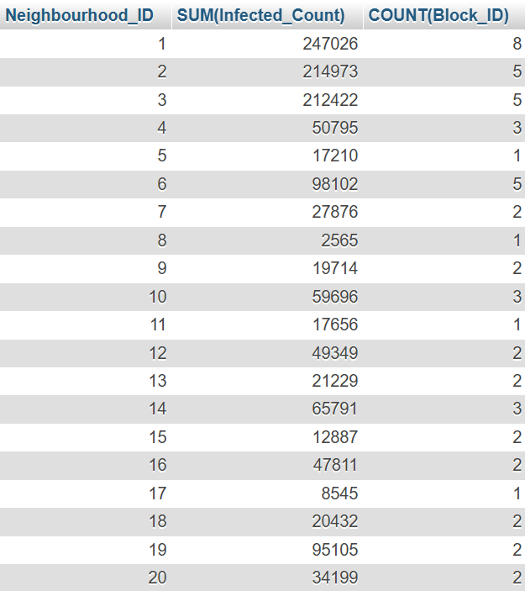

Query 5:
Purpose: To only show all the blocks and their infected counts in neighbourhoods 1, 2 and 3.
SELECT Block_ID, Neighbourhood_ID, Population, Infected_Count
FROM cityblock
WHERE Neighbourhood_ID IN (1, 2, 3);
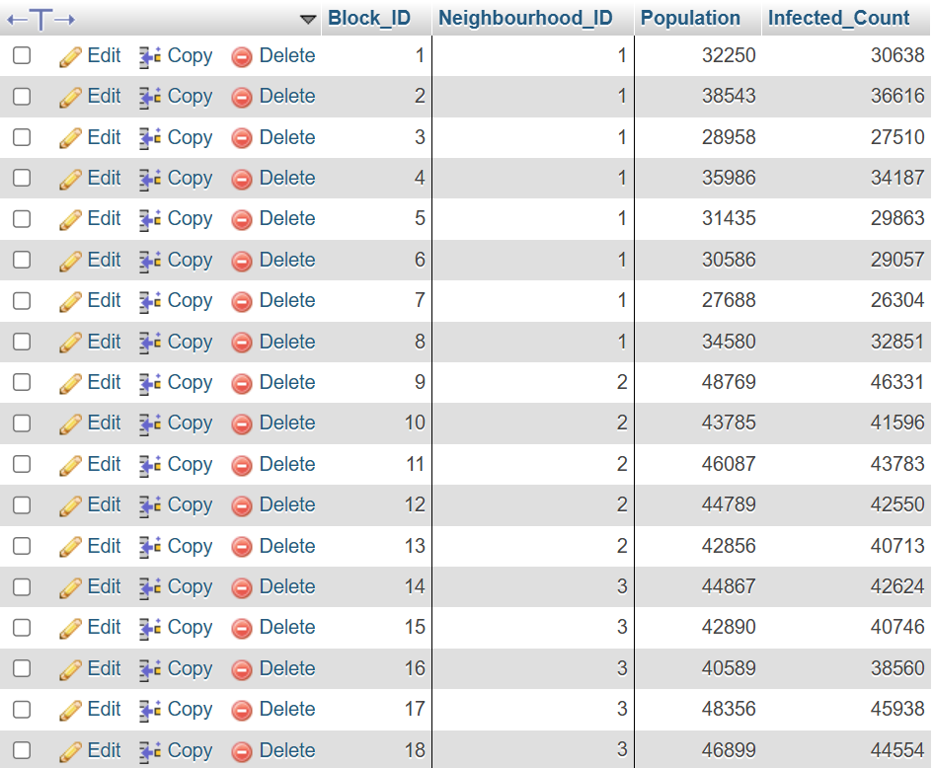

Query 6:
Purpose:
We have identified 3 rows where the total of the infected_count and recovered_count adds up to 1 number higher than the population. An example is row 1 where 30638 + 1613 is equal to 32251 which is not the population. We need to update them so the infected and recovered count add up to the population.
UPDATE cityblock
SET Recovered_Count = Recovered_Count - 1 -- de-incrementing the recovered count for certain rows
WHERE Block_ID IN (1, 15, 51);
Result:

